**IMPLEMENTATION OF AUGMENTED REALITY FOR DIGITAL CLASSROOM APPLICATIONS**

**A PROJECT REPORT**

***Submitted by***

**PENDYALA CHINMAYEE (17B91A12C7)**

**VEGESNA BALA SARASWATHI (17B91A12H1)**

**VALLU BHARATHI SRI (17B91A12G7)**

**PENMETSA SOWMYA (17B91A12D1)**

***Under the guidance of***

**Dr.B.D.V.S. Sekhar**

***in partial fulfillment for the award of the degree***

***of***

**BACHELOR OF TECHNOLOGY**

**IN**

**INFORMATION TECHNOLOGY**

**SAGI RAMAKRISHNAM RAJU ENGINEERING COLLEGE(AUTONOMOUS)**

**BHIMAVARAM, 534 204. ANDHRA PRADESH**

**2017-2021**

**SAGI RAMAKRISHNAM RAJU ENGINEERING COLLEGE (A) CHINAMIRAM, BHIMAVARAM-534 204.**

**BONAFIDE CERTIFICATE**

Certified that this project report ”**IMPLEMENTATION OF AUGMENTED REALITY FOR CLASSROOM APPLICATIONS** ” is the bonafide work of **PENDYALACHINMAYEE (17B91A12C7), VEGESNA BALA SARASWATHI(17B91A12H1), VALLU BHARATHI SRI(17B91A12G7), PENMETSA SOWMYA SRI(17B91A12D1)**” who carried out the project work under my supervision.

**SIGNATURE**

**Dr. Bh. Rama Krsihnam Raju V S**

**Professor**

Dept. ofInformationTechnology,

Sagi Rama krishnam Raju EngineeringCollege(A),

Chinamiram, Bhimavaram-534202



**SIGNATURE**

**Dr.B.D.V.S.SEKHAR**

**Assistant Professor**

Dept. ofInformationTechnology,

Sagi Rama krishnam Raju EngineeringCollege(A),

Chinamiram, Bhimavaram-534202

### SELF DECLARATION

We hereby declare that the project work entitled “IMPLEMENTATION OF AUGMENTED REALITY FOR DIGITAL CLASSROOM APPLICATIONS” is a genuine work carried out by us in B.Tech., Information Technology at SRKR Engineering College(A), Bhimavaram and has not been submitted either in part or full for the award of any other degree or diploma in any other institute or University.

1. **PENDYALA CHINMAYEE (17B91A12C7)**
2. **VEGESNA BALA SARASWATI (17B91A12H1)**
3. **VALLU BHARATHI SRI (17B91A12G7)**
4. **PENMETSA SOWMYA (17B91A12D1)**

**TABLE OF CONTENTS**

LISTOFFIGURES 1

ABSTRACT 2

1. INTRODUCTION 3-8
2. PROBLEM STATEMENT 9
3. LITERATURESURVEY 10-15
4. SOFTWARE REQUIREMENTSSPECIFICATION 16-33
   1. PURPOSE 16
   2. SCOPE 16
   3. OBJECTIVES 16-17
   4. EXISTING SYSTEM 17-19
   5. PROPOSED SYSTEM 19-32
   6. REQUIREMENTS 32-33
      1. FUNCTIONALREQUIREMENTS 32
      2. NON-FUNCTIONALREQUIREMENTS 32-33
      3. PSEUDO REQUIREMENTS 33
5. SYSTEM DESIGN 34-40
   1. SYSTEMARCHITECTURE 34
   2. UMLDESIGN 34-40
      1. USE CASE DIAGRAM 34-36
      2. CLASS DIAGRAM 36-37
      3. INTERACTION DIAGRAMS 37-40
         1. SEQUENCE DIAGRAM 37-38
         2. COLLABORATION DIAGRAM 38-39
      4. STATECHARTDIAGRAM 39-40
6. METHODOLOGY 41-53
   1. IMPORTING LIBRARIES 41-43
      1. NUMPY 41
      2. OPERATIONS USING NUMPY 41
      3. NUMPY- A REPLACEMENT FOR MATLAB 41-42
      4. OPENCV 42
      5. COMPUTER VISION 42
      6. FEATURES OF OPENCV LIBRARY 43
   2. IMAGE PROCCESSING 43-44
   3. FEATURE DETECTION AND MATCHING MODULES 44-53
      1. INTRODUCTION 44-45
      2. ORB 45
      3. FAST 45-47
      4. BRIEF 48-53
7. FEATURE DETECTION 54-55
   1. CODE 54
   2. OUTPUT 55
8. FEATURE MATCHING 56-59
   1. CODE 56-57
   2. OUTPUT 58-59
9. AUGMENTED REALITY 60-61
   1. CODE 60-61
   2. OUTPUT 61
10. VIRTUAL REALITY 62-66

10.1. CODE 62-65

10.2. OUTPUT 65-66

1. CONCLUSION 67
2. REFERENCES 68-70

# LIST OF FIGURES

|  |  |  |
| --- | --- | --- |
| 1.1 | Augmented Reality | 4 |
| 1.2 | Ivan Sutherland’s AR creation | 6 |
| 3.1 | HMD | 12 |
| 4.5.1 | Augmented storybook | 26 |
| 4.5.2 | Student interacting with real objects | 28 |
| 4.5.3 | AR example in biology | 29 |
| 4.5.4 | AR in physics | 30 |
| 4.5.5(a) | AR device | 31 |
| 4.5.5(b) | AR condition in study | 31 |
| 6.3.1.1 | Train key points with size | 44 |
| 6.3.1.2 | Train key points without size | 44 |
| 6.3.3.1 | Features from Accelerated segment | 46 |
| 6.3.3.2 | Example to ORB | 46 |
| 6.3.3.3 | Binary descriptors | 47 |
| 6.3.4.1 | Binary Features | 48 |
| 6.3.4.2 | Smoothed image patch | 49 |

# ABSTRACT

# In recent years, a new method of teaching has emerged, utilizing projectors to display the information to be taught. This method of instruction has evolved to include the use of tablets and cell phones in the classroom to record what has been taught. This has now been extended to include the use of augmented reality to show students the matching videos during an online class. This method of instruction will boost student enthusiasm and participation in class while also allowing for new forms of interaction and visualization. The pupils are shown a combination of a real scene and a virtual scene produced by a computer, which is known as augmented reality. An application for the digital classroom is provided in this study. Lecturers can display the virtual content on the screen using unique image cards. Feature detection and matching are used in this process of presenting the related videos. Object recognition, picture retrieval, and other computer vision applications all employ feature detection. Objects, edges, points, or any other type of relevant information can be included in these characteristics. And these traits are utilized to achieve computational problems in some applications. Lecturers can use augmented reality as a supplement to bring teachings to life. Traditional online lessons are enhanced with augmented reality, which adds a function that shows the needed video depending on the picture card displayed by the speaker.

**CHAPTER 1**

**INTRODUCTION**

Augmented Reality time period turned into coined withinside the year 1990 with the aid of using Tom Caudell however it turned into first invented with the aid of using the improvement of the primary head-set up show gadget with the aid of using Ivan Sutherland withinside the year 1968. From then the Augmented truth has grown plenty in tremendous ways. It combines actual and digital worlds with the aid of using such as the actual-time interplay and additionally the 3-D registration of actual and digital gadgets. AR is each interactive and 3-D recorded, and it combines real and digital gadgets. Milgram's Reality-Virtuality Experiment As proven in Fig.1.1 [2], a continuum that spans among the actual and digital environments is described with the aid of using Paul Milgram and Fumio Kishino as a continuum that incorporates Augmented Reality and Augmented Virtuality (AV) in among, in which AR is towards the actual international and AV is towards a natural digital surroundings. The aim of augmented truth is to make the user's existence less difficult with the aid of using introducing digital data now no longer simply to his instantaneously surroundings, however additionally to any oblique view of the actual-international surroundings, inclusive of a live-video feed. The user's angle of and interplay with the actual surroundings is advanced thru augmented truth. While Virtual Realism (VR) era, additionally referred to as the Virtual Environment, completely immerses customers in a artificial surroundings with out permitting them to view the real international, AR era complements the sensation of truth with the aid of using superimposing digital gadgets and alerts onto the actual international in actual time. We do now no longer regard AR to be restricted to a positive shape of show era, inclusive of a head-set up show (HMD), nor can we accept as true with it to be restricted to the experience of sight, as Azuma et al. [3] do. AR has the capacity to beautify all senses, such as smell, touch, and listening to. AR will also be used to complement or update customers' lacking senses thru sensory substitution, inclusive of the use of audio cues to enhance the sight of blind or low-imaginative and prescient customers, or the use of visible cues to enhance the listening to of deaf customers.

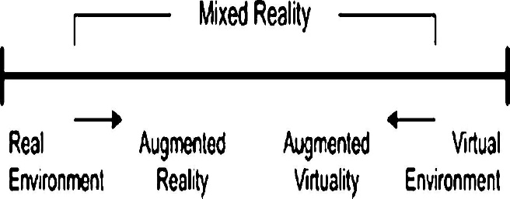

Fig 1.1

In addition to introducing virtual items, Azuma et al. [3] examined AR applications that involve eliminating actual elements from the environment, often known as mediated or reduced reality. Indeed, eliminating items from the actual world entails covering the object with virtual data that fits the background to give the user the sense that the object does not exist. The information sent on by the virtual item can assist the user in doing daily activities, such as guiding employees through electrical cables in an airplane using a headset to show digital information. Information can also be used for amusement purposes, as in Wikitude or other mobile augmented reality applications. Medical visualization, entertainment, advertising, maintenance and repair, annotation, robot path planning, and so on are all examples of AR applications.

The earliest appearance of Augmented Reality (AR) goes back to the 1950s, when Morton Heilig, a cinematographer, thought of film as an activity that could bring the audience into the onscreen experience by effectively incorporating all of the senses. Heilig created a prototype of his vision, Sensorama, in 1962, which preceded digital computers [4], which he outlined in 1955 in "The Cinema of the Future." Ivan Sutherland in 1966 (Fig.1.2) created a head mounted display in the year 1966. Sutherland was the first to use an optical see-through head-mounted display to build an augmented reality system in 1968 [5]. In 1975, Myron Krueger builds the Videoplace, a room that for the first time allows people to interact with virtual items. Later, while assisting employees with the assembly of cables and cabling for an aeroplane, Boeing's Tom Caudell and David Mizell coined the term Augmented Reality [1].

They also started talking about the benefits of Augmented Reality (AR) over Virtual Reality (VR), such as the fact that it uses less power because fewer pixels are required [5]. In the same year, L.B Rosenberg created one of the earliest working AR systems, Virtual Fixtures, and proved its impact on human performance, while Steven Feiner, Blair MacIntyre, and Doree Seligmann delivered the first significant article on an AR system prototype, KARMA [1.] The reality virtuality continuum depicted in Figure 1.1 was not established until 1994 by Paul Milgram and Fumio Kishino as a continuum spanning the actual and virtual worlds. AR and AV are both at the same place.

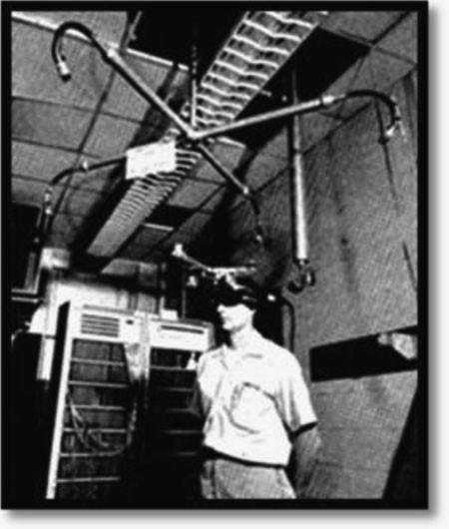

Fig. 1.2 Ivan Sutherland’s

HMD [5] in among with AR being in the direction of the actual-global surroundings and AV being in the direction of the digital surroundings. In 1997, Ronald Azuma writes the primary survey in AR offering a extensively stated definition of AR via way of means of figuring out it as combining actual and digital surroundings whilst being each registered in 3-d and interactive in actual time [5]. The first out of doors cell AR game, ARQuake, is evolved via way of means of Bruce Thomas in 2000and confirmed at some point of the International Symposium on Wearable Computers. In 2005, the Horizon Report [6] predicts that AR technology will emerge extra completely in the subsequent 4–five years; and, as to verify that prediction, digital digicam structures which can examine bodily environments in actual time and relate positions among gadgets and surroundings are evolved the equal year. This form of digital digicam machine has emerge as the idea to combine digital gadgets with fact in AR structures. In the subsequent years, increasingly AR packages are evolved particularly with cell packages, which include Wikitude AR Travel Guide released in 2008, however additionally with the improvement of clinical packages in 2007. Nowadays, with the brand new advances in generation, an growing quantity of AR structures and packages are produced, significantly with MIT sixth feel prototype and the discharge of the iPad 2 and its successors and competitors, significantly the Eee Pad, and the iPhone 4, which guarantees to revolutionize cell AR. Augmented Reality (AR) is a generation that permits pc-generated digital imagery data to be overlaid onto a stay direct or oblique actual-global surroundings in actual time. AR isn't the same as Virtual Reality (VR) in that during VR humans are anticipated to revel in a pc-generated digital surroundings. In AR, the surroundings is actual, however prolonged with data and imagery from the machine. In different words, AR bridges the distance among the actual and the digital in a unbroken way. According to the records of AR is going lower back to the Sixties and the primary machine turned into used for each AR and VR. It used an optical see-via headmounted show that turned into tracked via way of means of one in all one-of-a-kind methods: a mechanical tracker and an ultrasonic tracker. Due to the confined processing strength of computer systems at that time, best quite simple wireframe drawings can be displayed in actual time (Sutherland, 1968). Since then, AR has been positioned to apply via way of means of some of main agencies for visualization, schooling, and different functions. The time period ‘Augmented Reality’ is attributed to former Boeing researcher Tom Caudell, who's believed to have coined the time period in 1990. AR structures can both be marker-primarily based totally or markerless- primarily based totally. Marker-primarily based totally packages are produced from 3 primary additives which encompass a guide for presenting marker data, a gripper for purchasing data from the guide and changing it to any other form of data, and a dice for augmenting data into 3-d-rendered data on a screen. On the alternative hand, markerless-primarily based totally packages want a monitoring machine that entails GPS (Global Positioning System), a compass, and an photograph reputation tool as opposed to the 3 factors of maker-primarily based totally structures. Markerless packages have wider applicability due to the fact they feature everywhere with out the want for unique labeling or supplemental reference points. Several researchers have counseled that newbies can supporttheir motivation for mastering and decorate their instructional realism-primarily based totally practices with digital and augmented fact. In spite of a high-quality quantity of studies over the last decades, adopting AR in schooling and schooling remains pretty tough due to problems with its integration with conventional mastering methods, fees for the improvement and preservation of the AR machine, and preferred resistance to new technology.

Virtual Reality entails completely immersing oneself in a virtual environment in which everything we see is generated by a machine. Although virtual reality has been around for decades, the quality of the experience has significantly increased in recent years. Although early devices like the Virtual Boy and CyberMaxx attempted to create pseudo-virtual worlds, today's VR headsets like the Oculus Rift and HTC Vive deliver a far more immersive VR experience. The outside world is completely hidden when we put on these VR head-mounted displays, and we are staring into a completely computer-generated experience.

Virtual reality (VR) is a technology that allows users to interact with and experience a computer-generated environment. It has the potential to encourage the client to take part in the recovery program. Virtual reality comes in a variety of forms. In cognitive rehabilitation, both immersive and non immersive VR have been used. Due to the fact that immersive VR is more realistic and facilitates generalization to real-life performance, a significant number of patients with brain damage may experience cyber sickness and drop out of training.

**CHAPTER 2**

**PROBLEM STATEMENT**

Presenting corresponding lecture videos while teaching an online class is a major difficulty for lecturers. An automated Augmented reality app is designed in-order to ease their task. This app recognizes the hand gestures or image cards and plays the corresponding video to the students. In this way the task of lecturers to present the corresponding video without giving a pause to lecture becomes very easy. Lecturers can show the image cards to play a related video.

**CHAPTER 3**

**LITERATURE SURVEY**

Methods of Computer Vision in Augmented Reality Computer vision produces 3D virtual objects from the same perspective as tracking cameras capture photos of the real scene. Augmented reality picture registration employs a variety of computer vision techniques, the majority of which are connected to video tracking. There are usually two stages to these methods: tracking and reconstructing/recognizing. The camera images are first examined for fiducial markers, optical images, or interest locations.To understand the camera images, tracking can utilize feature detection, edge detection, or other image processing algorithms. The majority of existing tracking approaches in computer vision may be divided into two categories: feature-based and model-based. The connection between 2D image characteristics and their 3D world frame locations is discovered using feature-based approaches. Model-based approaches employ representations of the tracked objects' features, such as CAD models or 2D templates based on identifiable traits.Once a link between the 2D image and the 3D world frame has been established, the camera posture may be determined by projecting the feature's 3D coordinates into the observed 2D image coordinates and reducing the distance between them and their corresponding 2D features. Point features are frequently used to set restrictions for camera position estimation. The data from the first stage is used to reconstruct a real-world coordinate system in the reconstructing/recognizing stage.

Some approaches rely on the presence of fiducial markers in the environment or on objects with well-known 3D geometry. Others, such as Huang et al.’s device’s AR-View, have the scene 3D structure pre-calculated; nevertheless, the device must be immobile and its position must be known. If the complete scene isn't known ahead of time, the Simultaneous Localization and Mapping (SLAM) approach is used to map the relative positions of fiducial markers or 3D models. The Structure from Motion (SfM) method is employed when no assumptions about the scene's 3D geometry can be made. The SfM approach is separated into two parts: feature point tracking and estimation of camera parameters.

The sort of environment in which the AR device will be used, as well as the type of AR system, determine the tracking methods used in AR. The setting could be indoors, outdoors, or a mix of both. Similarly, the system could be mobile or stationary (have a fixed-position). For example, if the AR device is a fixed-position device for usage in an outdoor real environment, such as Huang et al AR-View, .'s the developers can employ mechanical tracking because the movements to be tracked will all be mechanical because the device's position is known.This type of environment and system facilitates environmental tracking for the purpose of enriching the surroundings. When the AR gadget is mobile and built for use in an outdoor environment, however, tracking becomes considerably more difficult, and different solutions provide distinct benefits and drawbacks. Nilsson et al., for example, used AR to create a pedestrian detecting system for car collision avoidance. Their solution is portable and may be used outside. The difficulty for computer vision in the case of a camera travelling in an unknown environment is to rebuild both the camera's motion and the scene's structure using the image and other sensor data sequences.Because no assumptions about the scene's 3D geometry can be made in this scenario, the SfM approach is employed to recreate the scene.

# 

Figure. 3.1 HMD

Because humans can detect an endless number of things and people in fractions of seconds, a recent novel method for breakthroughs in visual tracking has been to examine how the human brain recognizes items, commonly known as the Human Vision System (HVS). If the human brain's way of perceiving things can be represented, computer vision will be able to meet the obstacles it faces now and move forward.

Antonio-Jose and his colleagues have been experimenting with Augmented Reality to improve learning in physical education classes. They polled students at a neighboring college and separated them into two groups: control and experimental. The control group consists of students who are taught in a traditional manner without the use of technology resources, whereas the experimental group consists of students who have been taught in a more innovative manner, with the training process using augmented reality. Basic statistics such as mean, standard deviation, skewness, and kurtosis were utilized in the analytical procedure to determine the distribution.They utilized basic statistics including mean, standard deviation, skewness, and kurtosis to determine the distribution trend during the investigation. The magnitude of the effect is then determined using a student's t-test, Cohen's d, and biserial correlation. Some statistical techniques, such as Kappa and W, were used to supplement the first validation by determining the degree of agreement and significance of the specialists' judgments. They used 140 students in their study and found that the experimental group's responses were more scattered than the control group's, with kurtosis values ranging from +1.96 to -1.96.

Christian Grevisse, Carina Martins Gomes, and Steffen Rothkugel created a semantic platform for open educational augmented reality resources. In today's classrooms, tablet computers are becoming more ubiquitous, allowing students to use a variety of apps for note-taking and evaluation. Di Serio et al. looked at the influence of augmented reality on motivation in a visual arts class. Mitsuhara et al. used a paper-top interface to project learning information linked to the notes students were taking in an early research. The requirement for independent augmented reality experiences to be integrated into other educational apps led to the creation of the AR4OER2 platform.The basic idea is to keep all of the apps involved loosely linked, resulting in a scalable and adaptable ecosystem. The 4 AR scenarios presently indexed on AR4OER will be shown. Each scenario is focused on a different school subject. They were created using a range of computer languages, and the way the user interacted with the AR experience differed. They offered four examples from diverse educational fields, as well as explanations for how students may benefit from them.

Josef Buchner and Jörg Zumbach worked on Augmented Reality in teacher education. A framework for teachers to utilize to assist their knowledge of technology pedagogical material. Augmented reality has a lot of potential as a learning and instructional tool for developing and/or upgrading new learning environments. According to a recent review of the literature on learning and teaching with augmented reality, the majority of research has focused on student learning. This research study used the Learning Technology by Design approach as part of an in-service teacher-training course on AR deployment in the classroom.The question of whether and under what conditions certain instruction technologies are suitable arises, as it does with any ID issue. A thorough examination of how AR may contribute to learning environments is necessary, taking into consideration pedagogical content knowledge and the material itself, with specific attention paid to the TPCK-underpinnings. Model's The approach incorporates technical (TK, in this example in connection to AR) and didactical/pedagogical (CK and PK) viewpoints, as well as a third, enrichment level. AR can help all students go from their personal fundamentum to their personal additum, which is something that all teachers can benefit from.

For a STEM education group, V V Osadchyi, N V Valko, and L V Kuzmich cooperated on augmented reality technology. STEM education is structured around project-based activities that use a range of instructional methods and technology solutions. There are different forms of participant engagement within project activities. Apart from categorizing resources, the authors divide them into two groups based on user activity: active AR content production and passive AR content consumption.The use of augmented reality (AR) in STEM education research facilitates the production of three types of resources: electronic educational materials, systematic supervision, and content generation by teaching experts, and instructors. In the process of training future natural and mathematical disciplines instructors, further study into method definition and types of augmented reality deployment is required. It is decided what role the STEM approach with augmented reality plays in the teaching process.

Nilam Desai wrote an article in 2018 titled "Recreation of History Using Augmented Reality." The structure of a location, as well as the art produced in that area, may reveal its history and heritage. It's a hidden gem that reveals important details about our past. As a result, it's critical to keep it alive for the sake of the bloodline. For the past several years, historical sites have been harmed by pollution, maintenance difficulties, and tourism, with pollution being the most significant cause. We may utilize a variety of technologies to conserve these priceless relics of our past and legacy by allowing people to digitally view antiques, architectural monuments, and historic places.3D images assist in gaining a spatial perspective on any thing. Virtual reality allows users to interact with geographical information from cultural heritage sites in a virtual three-dimensional environment. The experience is multiplied if one can interact with the object by placing it in a real-world setting using augmented reality. Virtual archaeology, Virtual Museums, virtual and AR Heritage, and other applications have evolved from the newest technology aimed to enrich the virtual experience of cultural and archaeological historical places. Virtual high-definition interactive technology aids in the virtual recreation and reconstruction of damaged cultural sites.The use of AR-enabled software and hardware aids in the development of such applications. People can use hand-held devices such as mobile phones and tablets to see historical items utilizing Augmented Reality coupled with Virtual Reality.

**CHAPTER 4**

**SOFTWARE REQUIREMENT SPECIFICATION**

### PURPOSE:

* + - The system used in schools Teachers only have to provide the books and students can scan the book pages, bringing them to life on their phones.
    - Whereas students used to put together PowerPoint presentations, they can now use augmented reality to bring presentations to life.

### SCOPE:

Augmented reality (AR) has been quietly but steadily revolutionizing the education sector, digitizing classroom learning and making training more diverse and engaging, much like its precursor virtual reality. Educators must still examine what is worthwhile their investment and would help their curricula, especially with so many new inventions hitting the market every day. Because AR may not always respond to their needs, it is vital to grasp the technology and what it has to offer before making that decision.

In a word, mobile augmented reality may benefit learners of all ages, from preschoolers through primary school students, and all the way up to college and university students, if used wisely. Recently, augmented reality (AR) has been introduced to assist workers in many industries with on-the-job training and has been recruited inside specific sectors to help people understand complex topics and learn in an engaging manner.

### OBJECTIVE:

When students are more engaged in the subject, classes will be more effective and appealing to them. Augmented reality allows pupils to grasp a subject by combining a real and virtual scene, resulting in increased interest and enthusiasm among students.

* The purpose of augmented reality in the classroom is to boost students' passion and interest in their classes by incorporating a virtual and real-world setting.
* To improve efficiency, many approaches for recognizing characteristics in picture cards are used.

### EXISTING SYSTEM:

### 

* In the existing Augmented Reality system we login into the user interface and scan an object with the camera, this will be compared with the images in the database and the details of the object in the database which is similar to scanned image, will be provided as the output in the user interface.
* This system only provides the details of the object but what we aim in our project is to retrieve a video to a corresponding hand gesture.

**The Current position of AR in Education and Training:**

Many experts and scholars have been developing practical ideas and applications for the adoption of AR in both academic and corporate contexts over the last few decades. As a result of these investigations, some AR innovations have been developed and are being used to improve the efficiency of student and staff education and training. Furthermore, numerous studies are being conducted to increase the compatibility and usability of augmented reality in everyday life. However, numerous doubts remain about its application in education and training, including as cost effectiveness, the efficiency of AR teaching systems against traditional techniques, and so on.

**AR works in Education and Training:**

AR has a lot of promise for providing both effective contextual on-site learning experiences and spontaneous exploration and discovery of the interrelated nature of knowledge in the real world. During the previous two decades, AR has been used in both classroom and commercial settings, though not as extensively as traditional methods of education and training. Furthermore, now that the technologies that enable AR are much more powerful than ever before and small enough to deliver AR experiences to not only corporate but also academic venues via personal computers and mobile devices, a variety of educational approaches utilizing AR technology are more feasible.

**AR in School:**

Professionals and researchers have worked to incorporate augmented reality into classroom learning in topics such as chemistry, mathematics, biology, physics, astronomy, and other K-12 or higher education, as well as enhanced books and student guides. However, it is predicted that AR has not been widely adopted in academic contexts due to a lack of government funding and a lack of understanding of the need for AR in academic settings.

**AR in Higher Education:**

Higher education, like as universities and colleges, can benefit greatly from AR. Both schools' students can increase their knowledge and skills, particularly when it comes to complex theories or operations of systems or machines. For example, employing AR technology and contextually enriched engagement, students were able to accept and understand sophisticated mechanics and tough theories in higher education. The results revealed an augmented reality perspective of a pupil viewing a 3D model of a camshaft arrangement alongside a set of real engine components.

### PROPOSED SYSTEM:

**Augmented Reality for the Classroom**

Kids love AR simulations due to the fact they're like actual-existence video games. Teachers love them due to the fact they are able to differentiate practise and have interaction even the maximum reticent freshmen in gaining knowledge of any form of content material at the same time as working towards virtual age competencies.

Imagine a online game that takes location withinside the actual global— proper out of doors your lecture room! In this recreation, the gamers research that an alien spaceship has crashed on their college grounds, and that they should clear up a thriller: Each of the gamers, running in a crew of 4, has a function to play: chemist, cryptologist, pc hacker, or FBI agent. And every receives his or her very own GPS-enabled cell tool, which includes a phone or tablet, showing a map of the college grounds with virtual markers monitoring every player’s vicinity in addition to the places of digital humans and artifacts. Players should stroll to and look at those markers to accumulate proof as a way to in the end assist them clear up the thriller,

AR simulations permit college students to research content material at the same time as taking part head to head and interacting with a multimedia-more advantageous model of the sector round them. Although the era may also appear advanced, AR software program makes it smooth to expand content material-primarily based totally simulations as a way to captivate college students at the same time as coaching them standards-primarily based totally content material. The situation above describes an real lecture room lesson the usage of Alien Contact, a center college arithmetic AR simulation that makes a speciality of the mathematical idea of proportional reasoning. However, AR can paintings for any content material area. In fact, we additionally advanced an English language arts model and a blended math/ language arts model of Alien Contact.

After engaging in 17 implementations, normally at city public center colleges in or round Boston, Massachusetts, USA, throughout the 2007–08 college year, we decided that AR will increase instructional engagement with the aid of using tapping college students’ hobby in cell gadgets, differentiates practise with the aid of using personalizing statistics or obligations for college students, and creates located gaining knowledge of experiences. Here is the procedure we used and a few matters to hold in thoughts in case you need to create very own AR simulations to apply with college students.

Augmented fact has speedy emerge as one of the maximum famous developments amongst software program and hardware developers. Augmented fact permits humans to have interaction with their actual-global surroundings in an more advantageous way. Using exclusive forms of era, the surroundings is augmented with the aid of using the era. This can arise in lots of methods. On the extra complicated end, customers can get comments thru their experience of touch, their experience of smell, and their experience of sight and sound.

The era getting used modifications the user’s belief of the actual global. This isn't always digital fact, due to the fact digital fact tries to update the actual-global surroundings with a virtual one. Depending on how state-of-the-art the era, augmented fact can show visuals over the actual global, offer synthetic audio comments that’s now no longer honestly gift withinside the surroundings, and deliver numerous sorts of comments thru a user’s exclusive senses.

If this sounds complex, that’s due to the fact it may be. Advanced augmented structures consist of visible headsets and complex controls for interacting with the improved actual-global surroundings. However, there are lots less complicated methods of imposing augmented fact. This less complicated model of augmented fact may be accessed the usage of the equal equipment that maximum college students use each day – the present day mobileular phone. Smart telephones, specifically, have the cappotential to create an augmented fact experience.

As documented with the aid of using Forbes, there are more than one methods that augmented fact has been introduced to existence over cell telephones. The Gatwick app connects terminal beacons to cell telephones to assist passengers navigate the area. Meanwhile, IKEA’s app shall we humans experiment their rooms and remodel them on their cell monitors the usage of Ikea furniture. Sephora’s app shall we humans experiment their faces and attempt exclusive appears with the aid of using combining exclusive facial products.

**Concept Development**: Before begin constructing AR simulation the usage of software program, it's going to need to devise out the storyline, activities, and curriculum.

**Storyline**. To conceive an AR gaining knowledge of simulation, should begin with an actual hassle, an interesting storyline from which content material-primarily based totally obligations can emerge, unique content material, or a few mixture of those. Because AR complements fact, we endorse starting with an actual hassle, which permits to nest content material inside an interesting story. MIT, for example, created a recreation wherein college students decide a supply of polluted ingesting water, the usage of the close by Charles River as their recreation space. At a few places, college students regarded virtual interviews with scientists, and at others they in reality examined water samples.

To expand Alien Contact, we commenced with a storyline (an alien crash), content material desires (proportional reasoning), and virtual age competencies (collaboration, conversation, and hassle solving). It turned into hard to expand mathematical obligations that concurrently furthered the storyline, supported scholar content material gaining knowledge of and virtual age talent development, and engaged college students withinside the simulation. So, to hold content material central, we created a file that supplied overarching gaining knowledge of desires and specified the obligations and gaining knowledge of desires for every day of the unit.

**Role differentiation**: AR shall we customise the sport for exclusive college students or businesses of college students with the aid of using storyline, statistics, and content material-primarily based totally obligations. Although complicated to design, simulations with differentiated roles could make the content material handy and hard at the same time as strengthening conversation and collaboration competencies for all freshmen. Roles can permit for a jigsaw approach, with every scholar receiving exclusive statistics that they should proportion for the institution to continue in the sport.

AR software program allowed us to create as much as 4 variations of our simulation the usage of exclusive scripts for every function that correspond with every scholar’s talent level (despite the fact that we later observed that businesses of 3 are simpler to manage). For example, the chemist obtained extra hard mathematical obligations, and the hacker obtained extra guided obligations. At one college, we advanced an audio model of the sport for a visually impaired scholar. To ease the making plans of function differentiation, use tables to storyboard the content material and narrative contributions of every function, and keep in mind the usage of self-contained activities.

**Tasks**: Alien Contact blanketed some of obligations designed to have interaction college students in a digital thriller at the same time as motivating them to exercise proportional reasoning competencies. For example, withinside the Wing Model task, groups song a virtual marker on their cell gadgets to a wing version, that is honestly a latex triangle at the ground (see “Wing Model Task” on web page 18). Once a crew unearths the version, the pc hacker’s tool shows a file supplying a math hassle that, whilst solved, will permit her to “hack” right into a CIA database. She learns that, if the ratio of the hypotenuse of the wing to its shortest facet is five:3, the wing belongs to a navy craft. From his cell tool, the chemist learns that the wing version has been measured with protection pins which can be 1.five inches long. The institution research the markings at the version itself to decide the scale of the wing and evaluate it with the given ratio. After gathering records out of doors, the scholars pass inner to investigate it. This is once they decide the aliens’ intentions, justifying their function with mathematical proof.

**Designing an Augmented Classroom**

When it involves enforcing augmented truth era into the lecture room, there are some layout ideas that teachers ought to hold in mind. As mentioned via way of means of researchers Robert Miller and Tonia Dousay, the primary obligation of a trainer is to invite why. Why are they enforcing the era and the way do they intend to apply it to guide gaining knowledge of goals? Haphazardly introducing a era only for the sake of the usage of it won’t result in progressed outcomes. The fine position for augmented truth is as a supplementary tool, in preference to as a number one approach of turning in content. So, at the same time as instructors can use it to carry instructions to life, in addition they want to hold a focal point on extra conventional methods of turning in content. Augmented truth is fine acceptable to improving the ones conventional instructions in preference to performing as stand-on my own techniques of instruction. It’s additionally essential for instructors to recognise their classrooms. If their college students don’t own a positive degree of technological knowhow, they won’t be capable of paintings with augmented truth effectively. If instructors are hoping to apply such era, they ought to in all likelihood gauge their lecture room on the begin of the yr first. This is essential due to the fact Miller and Dousay counseled that seeking to use this era amongst college students who didn’t have a positive degree of technological competence might most effective detract from assembly gaining knowledge of goals.

**Using Augmented Reality in the Classroom**

With all this dialogue approximately the gear that instructors use and the advantages of augmented fact, how are instructors really setting the generation to apply withinside the class? Writing for Education Week Teacher, creator Kate Stoltzfus indexed strategies instructors need to use to combine augmented fact into the lecture room. This may also assist you combine augmented fact into your lecture room greater easily.

One of the number one approaches that instructors can ease the transition to augmented fact is through adopting gear that could practice to all grade degrees and talent degrees. A precise instance that educators used turned into Merge Cube. This dice is basically a hologram that scholars can control. Depending at the apps which are downloaded, the dice can grow to be many things – a globe college students can use to discover the arena, a multi sided sport that trains college students in approaches that sharpens their memory, an aquarium that scholars can use to become aware of numerous fish species, or a tool for rotating projections of the sun system. Merge Cube is simply one instance of a unmarried device that may be tailored for a couple of audiences the use of an abundance of unfastened apps. Tools that may be tailored to a couple of audiences can assist lessen the variety of assets instructors should are trying to find out to decorate their training.

Another manner that instructors are integrating augmented fact into their training is through giving college students possession of the training experience. Teachers regularly use augmented fact to supply content material via apps. However, college students can prepare their very own tasks the use of apps that could then be shared with the class.

Whereas college students used to prepare PowerPoint displays, they could now use augmented fact to carry displays to existence. Just one instance that educators supplied turned into using Google Street View. By drawing on pictures from Google Street View, college students created pictures that might be regarded at any angle. This helped them create perspectives of the arena that might be manipulated in 360 degrees. Such strategies helped to growth scholar engagement and get them doing arms on paintings in augmented fact.

Other approaches that instructors have incorporated augmented fact turned into mentioned at New Gen Apps, an agency that develops cellular programs for enterprise and training. One exciting manner to assist get college students familiar with their teachers may be performed the use of augmented fact. Schools can prepare a school image wall in which college students can use their gadgets to experiment every image. Then, on their screens, the images will come to existence and offer extraordinary statistics approximately their instructors. This may be mainly useful the primary week of faculty as college students are first getting familiar with their teachers. Using this approach, a singular and amusing manner of studying approximately a faculty’s group of workers may also assist college students transition into the faculty year.

Science instructors have extensively utilized augmented fact to offer college students with a greater enticing manner of studying approximately lab protection. Using triggers across the lecture room, technological know-how teachers can carry caution approximately lab gadgets to existence. As college students stroll via the lab, their gadgets can experiment those tags and study extraordinary guidelines they need to adhere to whilst walking extraordinary lab experiments and running with extraordinary equipment.

It’s clean that there are numerous exciting approaches that instructors are the use of augmented fact withinside the class. It may be used to educate guidelines and protection protocols, introduce college students to their teachers, empower college students to create their very own three-d displays, or control adaptable gear that could educate extraordinary instructions relying at the app that’s downloaded. However, due to the fact augmented fact stays a pretty new discipline in training, researchers and educators are certain to find out new approaches of the use of the generation withinside the future.

**Reading comprehension**

Story recall and reading comprehension are two areas in which we have seen positive educational results. In Figure 4.5, children are reading an augmented storybook and using handheld paddles to move virtual characters and solve simple puzzles. The children work in pairs, which facilitates collaborative problem solving and increases their chances of finding new solutions.



Figure 4.5.1 Working in pairs, youngsters use paddles to transport digital characters and remedy puzzles.

The augmented ee-e book combines text-primarily based totally sections and interactive AR sections. We in comparison how tons readers with excessive and occasional cap potential (teacher-supplied classifications) remembered from the 2 media formats. From text-primarily based totally tale sections, the ones withinside the excessive-cap potential institution ought to retell notably extra key tale factors than the low-cap potential institution. However, the 2 organizations confirmed no considerable distinction in recalling key tale factors from the interactive AR sections. Arguably then, due to the fact they offer an possibility for interactive content material engagement, augmented books ought to advantage college students who're much less capable of recognize text-primarily based totally getting to know substances presently the major schooling medium

**AR in K-12 Settings**

The SMART (System of augmented reality for teaching) that is an educational system using AR technology. This technique use augmented reality to teach 2nd grade concepts such as modes of transportation and animal sorts. This method superimposes three-dimensional models and prototypes, such as a car, truck, or aero plane, on a live video feed that is broadcast to the entire class. Game-based learning is one technique to interest youngsters in learning because they spend so much time playing digital games. Several trials were conducted with 54 pupils in three distinct Portuguese schools. According to the findings of a number of studies, SMART helps students become more motivated and has a favorable impact on their learning experiences Particularly among students who are less academically successful.



Figure 4.5.2 A view of a student interacting with real objects (foam core card, table, wall) and artificial objects (Sun, Earth, annotations) through the augmented reality interface. This view is as would be seen if wearing an HMD (Shelton, 2002).

**The Application of AR in Different Subjects**

Astronomy with enhanced capabilities. Students learn about the earth's and sun's interaction in an astronomy class.Educators can employ AR technology to assist student comprehension by using 3D rendered earth and sun shapes.

1. **Augmented biology**

In biology, AR can be used to examine the anatomy and structure of the body. Teachers might utilize AR technology to highlight what human organs are made of and how they look by watching 3D computer-generated models in real classrooms, according to the Specialist Schools and Academies Trust (SSAT).Furthermore, using theircamera-embedded laptops and AR markers that connect PCs with AR information about biological features of the human body, students may be able to study human organs autonomously.



Figure 4.5.3: An augmented fact version of a human's inner organs that maybe utilized in Biology lesson.

1. **Mathematics and geometry education.**

With AR technology, instructors and college university students can collaborate through interacting with every precise for a few troubles on shapes or arrangements

According to Chang an AR utility, called Construct3D, especially have become designed for mathematics and geometry education with three-dimensional geometric advent models. This software program lets in multiple clients, on the aspect of instructors and college students, to percentage a digital area collaboratively to bring together geometric shapes via carrying head set up displays that permit clients to overlay computer-generated photos onto the real world. AR can be applied in dynamic differential geometry education in a big type of ways. For instance, the usage of the AR utility, teachers and university college students can intuitively find out houses of thrilling curves, surfaces, and unique geometric shapes.

1. **Physics education:**

Physics is any other region in AR also can be used to illustrate numerous kinematics properties. AR to dynamically gift an item that varies in time, which include speed and acceleration. The actual and envisioned experimental effects may be visualized through the use of AR strategies which might be extra thrilling than present getting to know methods, and hence enhance getting to know. The physics simulation is brought to gadgets the use of open dynamics engine (ODE) library.



Figure 4.5.4: Students running with construct3D inscribe a sphere in a cone

We utilized the openCV package in Python to identify the picture card displayed by the lecturer, analyze it, and compare it to an image in the database to achieve augmented reality courses. Numpy is also used to do

1.mathematical and logical calculations

2.fourier transformations

3.shape manipulation routines

OpenCV stands for "Open Computer Vision," and it's used to conduct things like image processing, pattern recognition, and photogrammetry, all of which will be covered in the pseudo-requirements section.

1. **AR applied to Books:**

By incorporating augmented reality technology into a book, it can become "magic." By superimposing 3D produced models onto books with AR technology, young children, in particular, may read books in more interactive and realistic ways. This is known as "The Magic-Book," and it uses both a regular book and a handheld see-through AR technology to make people's fantasies of becoming a part of the storey a reality. Without any interactive aid, people can turn the pages of a book, look at pictures, and read the text (figure 4.4).



Figure 4.5.5

a) A mechanic wearing a tracked head-worn display performs a maintenance task inside an LAV-25A1 armored personnel carrier.

b) The AR condition in the study: A view through the head-worn display captured in a similar domain depicts information provided using augmented reality to assist the mechanic

They can see three-dimensional models pop out of the pages if they gaze at the pages using a handheld AR monitor (figure 4.4b). People can see 3D sceneries from any perspective simply by moving the AR device or the book, as illustrated by the MagicBook and the AR see-through gadget. The Magic Book is a three-dimensional "pop-up" book that has been upgraded. Furthermore, after publishing, augmented books can be turned into an AR edition by installing special software called AR tool kits on users' computers and directing their computers' embedded cameras at the book to view computer-generated 3D models that pop out of the book.

### REQUIREMENTS:

### FUNCTIONALREQUIREMENTS:

### Start Camera: The front camera is accessed in order to retrieve or capture the image card shown by the lecturers.

### Detect Object: The camera video is divided into frames and the image card(frame) is detected.

### Create AR objects: An AR object will be created and shown on the screen based on the image card shown.

### Place AR objects: Based on the sensor the created video will be appended on the screen without any disturbance or obstruction.

### Support of Interactive AR content

### Indirect retrieval of AR content

### Visual composition of AR content

### NON- FUNCTIONALREQUIREMENTS:

### Usability: This is mainly about the view of the app and the user interface.

### Reliability/Availability: Requirement of the app whether it has to work 24/7 or not.

### Scalability: This is about the handling of the system incase of future enhancements.

### Performance: It is about the efficiency or how fast it operates.

### Security

### PSEUDO REQUIREMENTS:

**Software Requirement:**

The Following are the software requirement necessary of the project:

* + - * OpenCV, Numpy
      * Operating system : WindowsXP.
      * Coding Language : Python

### Hardware Requirement:

The Following are the hardware requirement that are most important for the project:

* Hard Disk : 40 GB.
  + - * Floppy Drive : 1.44 Mb.
      * Monitor : 15 VGAColour.
      * Mouse : Logitech.
      * Ram : 4GB
      * Web Camera

Fluently working Laptops

### CHAPTER 5

### SYSTEM DESIGN

### SYSTEMARCHITECTURE

ORB based object recognition

Input line Video feed

AR video overlapping

### UMLDESIGN

### Use Case Diagram

A use case diagram is the representation of a user's interaction with the system and depicts the specifications of a use case. A use case diagram can portray different types of system users and different in which they interact with the system. This type of diagram is typically used in conjunction with the textual use case and will often be accompanied by other types of diagrams as well.



### Fig. 5.2.1 Use Case diagram



### Fig. 5.2.1.1 Sub Use Case diagram for scanning image

### 

### Fig. 5.2.1.2 Sub Use Case diagram for viewing video

### Class Diagram

Class diagrams are the main element of object-oriented modeling. They are used to exhibit different objects in a system, their attributes, their operations and the relationships among them.In the diagram, classes are declared using boxes and each box contains three parts:

* The upper portion carries the class name.
* The middle portion carries the class attributes.
* The last portion carries the methods or operations that are taken or undertaken by class.



### Fig. 5.3 Class diagram

* + 1. **Interaction Diagram**

The interaction diagram shows some kind of interactions among the different elements in the model. This interaction is a part of the system's dynamicbehavior.

This interactive behavior in UML is illustrated by 2 diagrams. They are Sequence diagram and Collaboration diagram.

### Sequence diagram

A sequence diagram shows how processes operate with each other and in what order. The sequence diagram shows the message flow in the system. It visualizes several dynamic scenarios. It showsthe interaction between any 2 lifelines as a time-ordered sequence of events, such that those lifelines took part at the run time. Here, the lifeline is indicated by a vertical bar, whereas the message flow is indicated by a vertical dotted line that extends till the page bottom.



### Fig. 5.4 Sequence diagram for Scanning the image

### Collaboration diagram

A collaboration diagram indicates the interactions among objects in terms of sequenced texts. Collaboration diagram is represented by a combination of data taken from class, sequence and use case diagrams describing both the system's static structure and dynamic behavior.



### Fig. 5.5 Collaboration diagram for scanning the image

**5.2.4 State Chart diagram**

The Statechart diagram shows the order of states undergone by an object within the system. It captures the software system's behavior. It models the class behavior, a subsystem, a package, and a complete system.



### Fig. 5.6 State Chart diagram for Scanning Image

### 

### Fig. 5.6.1 State Chart diagram viewing video

**CHAPTER 6**

**METHODOLOGY**

The System follows the following methodology:

First the video that is being captured is divided into frames using python and then this image is compared to the images in the database and the most similar image is determined by applying orb technique in python. And some other modules that are used in image matching are given below.

**6.1 Importing Libraries:**

**6.1.1 Numpy:**

It's a library that includes multidimensional array objects as well as array processing algorithms. Numeric, the predecessor to NumPy, was designed by Jim Hugunin. Numarray, a new package with more functionality, was also built. In 2005, Travis Oliphant created the NumPy package by merging the Numarray and Numeric packages. A significant number of people have contributed to this open-source project.

**6.1.2 Operations using NumPy**

Using NumPy, a developer can perform the following operations:

* Mathematical and logical operations on arrays.
* Fourier transforms and routines for shape manipulation.
* Operations related to linear algebra. NumPy has in-built functions for linear algebra and random number generation.

**6.1.3 NumPy – A Replacement for MatLab**

NumPy is frequently used in conjunction with SciPy (Scientific Python) and Matplotlib (plotting library). This combo is frequently used as a substitute for MatLab, a popular technical computing platform. The Python counterpart to MatLab, on the other hand, is currently regarded as a more contemporary and comprehensive programming language.

NumPy has the extra benefit of being open source.

The NumPy module is not included in the standard Python distribution. Installing NumPy with the common Python package installer is a lightweight approach.

$$pip. pip install numpy$$

The best way to activate NumPy is to use an installable binary package customized to your operating system. These binaries contain the entire SciPy stack (inclusive of NumPy, SciPy, matplotlib, IPython, SymPy and nose packages along with core Python).

**6.1.4 OpenCv**

It focuses primarily on image processing, video recording, and analysis, including capabilities such as face detection and object detection. Let's begin by defining the phrase "Computer Vision" in this chapter.

**6.1.5 Computer Vision**

Computer vision is a discipline that describes how to rebuild, interrupt, and comprehend a 3D scene from its 2D pictures in terms of the structure inherent in the scene. It is concerned with utilizing computer software and technology to mimic and replicate human vision.

Computer Vision overlaps significantly with the following fields:

* Image Processing: It focuses on image manipulation.
* Pattern Recognition: It explains various techniques to classify patterns.
* Photogrammetry: It is concerned with obtaining accurate measurements from images.

**6.1.6 Features of OpenCV Library**

Using OpenCV library

* Read and write images
* Capture and save videos
* Process images (filter, transform)
* Perform feature detection
* Detect specific objects such as faces, eyes, cars, in the videos or images.
* Analyze the video, i.e., estimate the motion in it, subtract the background, and track objects in it.

**6.2 Image Processing**

Image processing is a technique for converting an image to digital form and then performing operations on it to create a better image or extract relevant information. It's a signal distribution method in which the input is an image, such as a video frame or a photograph, and the output is an image or image-related features. Typically, an Image Processing system treats pictures as two-dimensional signals that are subjected to pre-determined signal processing algorithms. It is one of today's fastest-growing technologies, with applications in a variety of industries. Image processing is a major research topic in both engineering and computer science.

**Image processing basically includes the following three steps:**

* Importing the image via image acquisition tools.
* Analyzing and manipulating the image.
* Output in which result can be altered image or report that is based onimage analysis.

***Low-level image processing algorithms include:***

* Edge detection
* Segmentation.
* Classiﬁcation.
* Feature detection and matching

**6.3 Feature Detection and Matching Modules:**

**6.3.1 Introduction:**

In the OpenCV laboratories in 2011, Ethan Rublee, Kurt Konolige, Vincent Rabaud, and Gary R. Bradski developed Oriented FAST and Rotated BRIEF (ORB) as an effective and viable alternative to SIFT and SURF. ORB was invented since SIFT and SURF are patented algorithms.

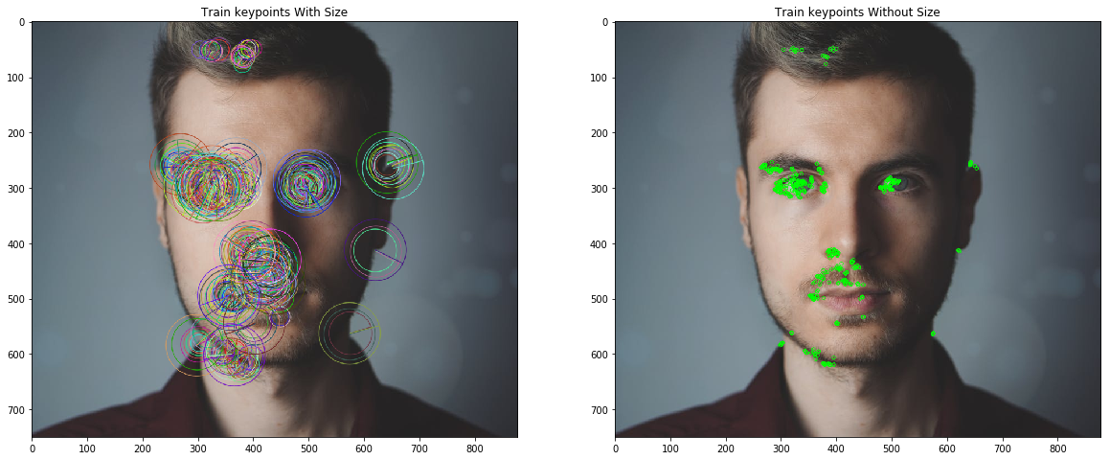

Figure 6.3.1.1 Figure train key points with Size

Figure 6.3.1.2 Train key points without size

In terms of feature detection, ORB surpasses SIFT (and SURF) despite being almost two orders of magnitude faster. The ORB descriptor is based on the well-known FAST keypoint detector. Both of these methods are appealing due to their high efficiency and low cost. The following are ORB's major contributions:

• The efficient calculation of oriented BRIEF features

• The inclusion of a quick and accurate orientation component to FAST

• A learning technique for decorrelating BRIEF features under rotational invariance, leading to higher performance in nearest-neighbor applications

• Analysis of variance and correlation of oriented BRIEF features.

**6.3.2 ORB:**

ORB is a BRIEF-described modified FAST key point detector. It uses FAST to discover the most important points first. The Harris corner measure is then used to identify the top N points. The orientation is not computed by FAST since it is rotation variation. With the corner in the center, it calculates the patch's intensity weighted centroid. The direction of the vector from this corner point to the centroid determines the orientation. Moments are computed to improve rotation invariance. The descriptor BRIEF works poorly when there is an in-plane rotation. The patch's orientation is used to produce a rotation matrix in ORB, and the BRIEF descriptors are then directed appropriately.

**6.3.3 Fast (Features from Accelerated and Segments Test)**

For a given pixel p the fast algorithm compares the brightness of p to its surrounding 16 pixels. Those surrounding pixels are then sorted into three classes (pixels lighter than p, pixels darker than p and pixels similar to p). A pixel p is selected as a key point if it has more than 8 pixels darker or brighter than p in its surrounding. This Fast determines the edges in an image So keypoints found by fast gives us information of the location edges in an image.

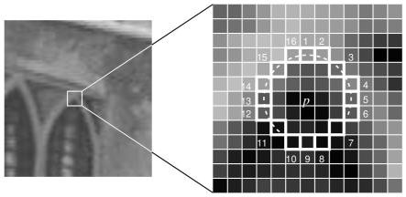

Figure 6.3.3.1 Features from Accelerated Segment

FAST characteristics, on the other hand, lack an orientation component and multiscale features. As a result, the orb method employs a multiscale image pyramid. An image pyramid is a multiscale depiction of a single image made up of a series of images, each of which is a different resolution version of the image. In the pyramid, each level has a down sampled version of the image from the previous level. Orb employs the quick method to detect key-points in the image after it has formed a pyramid. Orb effectively locates key points at a different scale by recognizing keypoints at each level. ORB is partial scale invariant in this way.

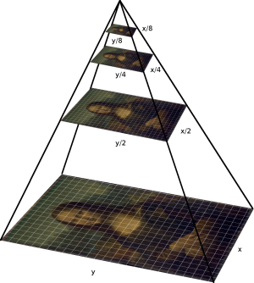

Figure 6.3.3.2 Example to ORB

After locating keypoints, orb now assigns each keypoint an orientation, such as left or right facing, based on how the intensity levels fluctuate around that keypoint. Orb employs intensity centroid to detect intensity changes. The intensity centroid posits that the intensity of a corner is offset from its centre, thus it can be used to infer an orientation.

To begin, a patch's moments are defined as follows:

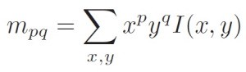

*ORB descriptor-Patch’s moment’s definition*

With these moments can find the centroid, the “center of mass” of the patch as:

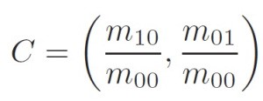

*ORB descriptor — Center of the mass of the patch*

Here constructs a vector from the corner’s center O to the centroid -OC. The orientation of the patch is then given by:

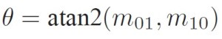

*ORB descriptor — Orientation of the patch*

Here is an illustration to help explain the method:

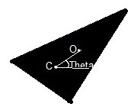

Figure 6.3.3.3 Binary descriptors

Once the patch's orientation has been determined, it can be rotated to a canonical rotation and the descriptor computed, resulting in rotation invariance.

**6.3.4 Brief (Binary robust independent elementary feature)**

Brief converts all of the keypoints obtained by the fast algorithm into a binary feature vector, which may then be used to represent an object. A binary feature vector, also known as a binary feature descriptor, is a feature vector that contains just the numbers 1 and 0. In a nutshell, each keypoint is represented by a feature vector, which is a 128–512 bit string.



Figure 6.3.4.1 Binary features

To prevent the descriptor from being susceptible to high-frequency noise, begin by smoothing the image with a Gaussian kernel. Then, in a defined neighborhood surrounding that keypoint, choose a random pair of pixels. A patch is a square of some pixel width and height that defines the defined neighborhood around a pixel. The first pixel in the random pair is selected from a Gaussian distribution with a stranded deviation or spread of sigma centered around the keypoint. The second pixel in the random pair is taken from a Gaussian distribution with a standard deviation or spread of sigma by two, centered around the first pixel. If the first pixel is brighter than the second, it assimilates the information.

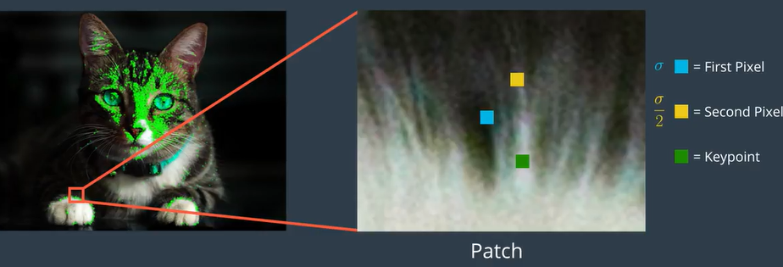

Figure 6.3.4.2 smoothed image patch

Select a random pair and assign the value to them once more. For a keypoint in a 128-bit vector, repeat this operation 128 times. For each keypoint in an image, build a vector similar to this. BRIEF is not invariant to rotation, thus orb uses rBRIEF instead (Rotation-aware BRIEF). ORB seeks to incorporate these capability while maintaining BRIEF's speed.

Consider an image patch that has been smoothed, p. A binary test is defined as follows:

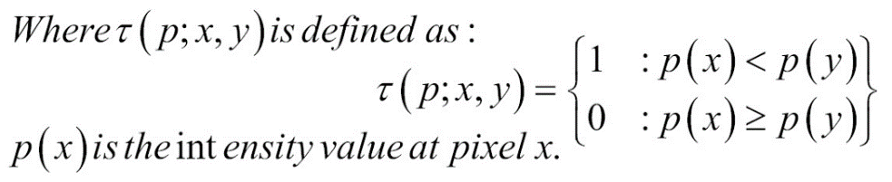

where p(x) is the intensity of p at a point x. The feature is defined as a vector of n binary tests:

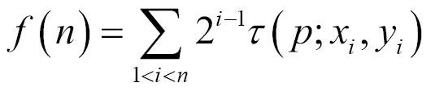

For in-plane rotations of more than a few degrees, BRIEF's matching performance plummets. ORB presents a method for steering BRIEF based on the keypoints' orientation. The 2 x n matrix is required for any feature set of n binary tests at point (xi, yi):

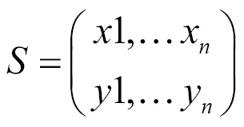

It uses the patch orientation θ and the corresponding rotation matrix Rθ, and construct a steered version Sθ of S:

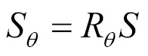

Now, the steered BRIEF operator becomes:

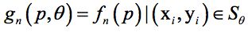

The angle is then discretized into 2/30 (12 degree) increments, and a lookup table of precomputed BRIEF patterns is created. The right collection of points S will be used to compute its descriptor as long as the keypoint orientation is consistent across views.

The rBRIEF algorithm is defined as follows by ORB:

1) Compare each test to all of the training patches.

2) Form the vector T by ordering the tests by their distance from a mean of 0.5.

3) Greedy hunt:

• Remove the first test from T and place it in the result vector R.

• Compare the results of the next test in T to the results of all tests in R. If the absolute correlation is larger than a threshold, it is discarded; otherwise, it is added to R.

• Carry on with the previous step.

While the use of ORB, you could byskip the following. The commented values are endorsed as in keeping with the docs, however it failed to offer required consequences in a few cases. Other values labored fine.:

**Matcher based on FLANN:**

Fast Library for Approximate Nearest Neighbors (FLANN) is an acronym for Fast Library for Approximate Nearest Neighbors. It includes a series of techniques that are optimized for rapid nearest neighbor searches in huge datasets and high-dimensional characteristics. For large datasets, it is faster than BFMatcher. The second example will use a FLANN-based matcher.

We must supply two dictionaries to the FLANN based matcher, one of which specifies the method to be utilized, as well as its relevant parameters. The first is IndexParams. The information to be passed for various algorithms is specified in FLANN documentation. In conclusion, for algorithms like as SIFT, SURF, and others.

The SearchParams dictionary is the second dictionary. It defines the number of times the index's trees to be explored recursively. Higher values provide more precision, but they also take longer. Pass search params = dict(checks=100) if you wish to adjust the value.

The matcher can be created as follows:

matcher=cv.DescriptorMatcher('FlannBasedMatcher',...'Index','KDTree','Trees',5,'FlannBasedMatcher',... 'Index','KDTree','Trees',5')

You can use ORB to pass the following parameters. The comments values are recommended in the documentation, however they didn't always produce the desired effects. The following values worked perfectly:

percent'LSH','TableNumber',12,'KeySize',20,'MultiProbeLevel',2 matcher=cv.DescriptorMatcher('FlannBasedMatcher',...'Index','LSH','TableNumber',6,'KeySize',12,'MultiProbeLevel',1

Search is the second option. It defines the number of times the index's trees to be explored recursively. Higher values provide more precision, but they also take longer.

If you wish to alter the value, use the following syntax:

matche=cv.DescriptorMatcher('FlannBasedMatcher', 'Search','Checks',10)

With FLANN, you can match features.

1.Basic understanding 1.Lowe's algorithm

This is referred to as "going to get fine" in order to further filter the matching points in order to acquire good matching points. Lowe's technique is commonly used to generate even better matching points. Due to image occlusion and backdrop confusion, it is necessary to delete crucial locations that do not have a matching relationship.

Lowe, a SIFT author, proposed a SIFT matching approach that compares the distance between the nearest neighbor and the second nearest neighbor: Take a SIFT key point in an image and discover the first two key points with the shortest Euclidean distance to another image.

Accept this A pair of matching points if the ratio produced by dividing the closest distance by the next closest distance is less than a specific threshold T. Because there may be a huge number of other false matches at similar distances due to the high dimensionality of the feature space, the ratio value for erroneous matching is relatively high.

Clearly, lowering the proportional threshold T reduces the amount of SIFT matching points while increasing stability, and vice versa.

The second-to-k nearest-neighbor algorithm,

The K-Nearest Neighbor (KNN) classification technique is a well-established theoretical method and one of the most straightforward machine learning methods. The premise behind this method is that if the majority of a sample's k most comparable samples in the feature space (that is, the sample's nearest neighbors in the feature space) belong to the same category, then the sample does as well.

**Approaches:**

**Multiple Randomized k- d Tree Algorithm:**

• Multiple trees are searched in parallel

• The splitting dimension is chosen at random from the top ND dimensions with the highest variation • ND is set to 5

• Typically, 20 trees are used.

• Best results in the majority of data sets

**The priority search k- Means Tree algorithm:**

•Partitioning data into K different regions

•Recursively partitioning each zone until there are no more than K items in the leaf node

•Picking up the initial center’s using Gonzales' random selection algorithm

•I max is the number of iterations of making regions

•Better performance for greater precisions than the k-d tree

**Experiments:**

**Data Dimensionality**

• Has a significant impact on nearest neighbor matching performance

• Performance reduces or increases in direct proportion to the type of data

• For random data samples, performance decreases dramatically.

**CHAPTER 7**

**FEATURE DETECTION**

**7.1 CODE**

import cv2

import numpy as np

#Getting the Image ready for feature detection

input_image = cv2.imread('Phishing.jpg')

input_image = cv2.resize(input_image, (400,550),interpolation=cv2.INTER_AREA)

gray_image = cv2.cvtColor(input_image, cv2.COLOR_BGR2GRAY)

# Initiate ORB object

orb = cv2.ORB_create(nfeatures=1000)

# find the keypoints with ORB

keypoints, descriptors = orb.detectAndCompute(gray_image, None)

# draw only the location of the keypoints without size or

final_keypoints = cv2.drawKeypoints(gray_image, keypoints,input_image,(0,255,0))

cv2.imshow('ORB keypoints', final_keypoints)

cv2.waitKey()

**7.2 OUTPUT:**

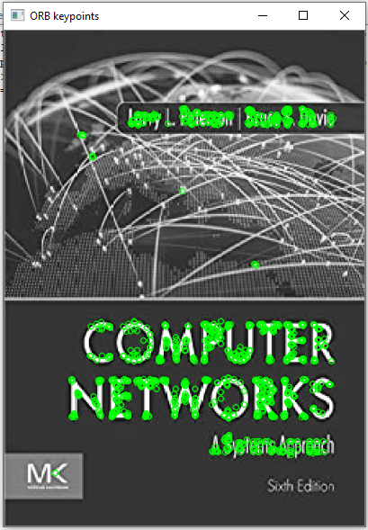

**CHAPTER 8**

**FEATURE MATCHING**

**8.1 CODE**

import cv2

import numpy as np

#Initilizing the ORB Feature Detector

MIN_MATCHES = 20

detector = cv2.ORB_create(nfeatures=5000)

#Preparing the FLANN Based matcher

index_params = dict(algorithm = 1, trees=3)

search_params = dict(checks=100)

flann = cv2.FlannBasedMatcher(index_params,search_params)

#Function for Loading input image and Keypoints

def load_input():

input_image = cv2.imread('piston-mech.jpg')

input_image = cv2.resize(input_image, (400,550),interpolation=cv2.INTER_AREA)

gray_image = cv2.cvtColor(input_image, cv2.COLOR_BGR2GRAY)

# find the keypoints with ORB

keypoints, descriptors = detector.detectAndCompute(gray_image, None)

return gray_image,keypoints, descriptors

if __name__=='__main__':

#Getting Information form the Input image

input_image, input_keypoints, input_descriptors = load_input()

#Getting camera ready

cap = cv2.VideoCapture(0)

ret, frame = cap.read()

while(ret):

ret, frame = cap.read()

#Condition Check for error escaping

if(len(input_keypoints)<MIN_MATCHES):

continue

#Resizing input image for fast computation

frame = cv2.resize(frame, (700,600))

frame_bw = cv2.cvtColor(frame, cv2.COLOR_BGR2GRAY)

output_keypoints,output_descriptors= detector.detectAndCompute(frame_bw, None)

matches = compute_matches(input_descriptors, output_descriptors)

if(matches!=None):

output_final = cv2.drawMatchesKnn(input_image,input_keypoints,frame,output_keypoints,matches,None,flags=cv2.DrawMatchesFlags_NOT_DRAW_SINGLE_POINTS)

cv2.imshow('Final Output', output_final)

else:

cv2.imshow('Final Output', frame)

key = cv2.waitKey(5)

if(key==27):

break

**8.2 OUTPUT:**

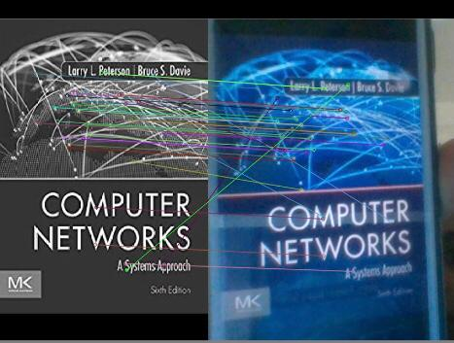

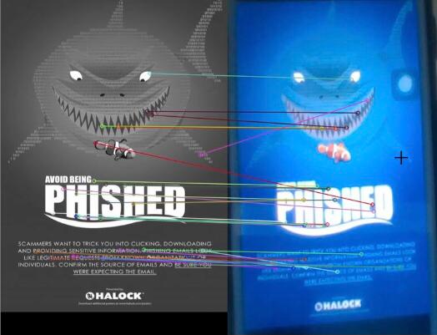

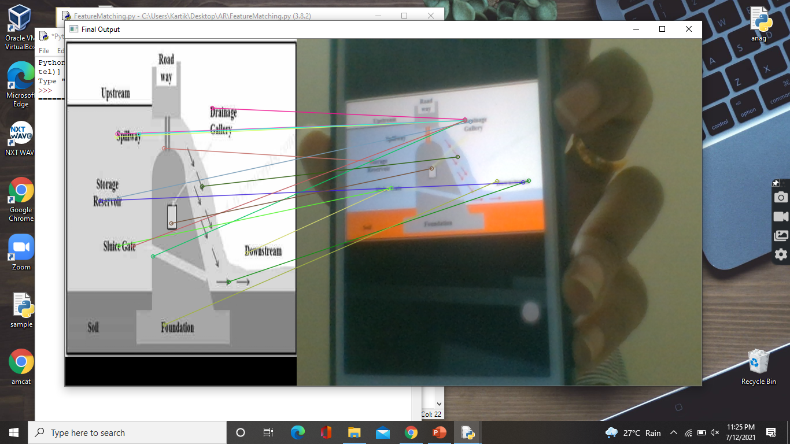

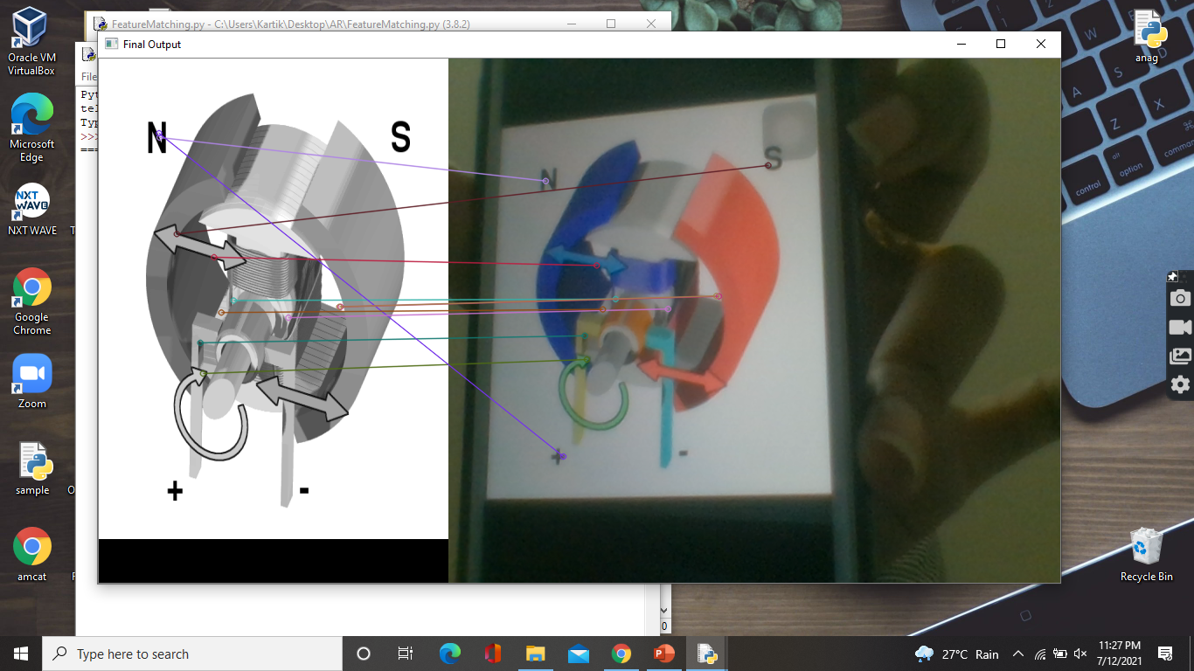

**CHAPTER 9**

**AUGMENTED REALITY**

Firstly the video is divided into frames using openCV. Then when an image card is shown a part of the real screen is masked and these frames are displayed one after the other in sequence which resembles a video.

**9.1 CODE:**

import cv2

import numpy as np

MIN_MATCHES = 20

detector = cv2.ORB_create(nfeatures=5000)

index_params = dict(algorithm = 1, trees=3)

search_params = dict(checks=100)

flann = cv2.FlannBasedMatcher(index_params,search_params)

def load_input():

input_image = cv2.imread('piston-mech.jpg')

input_image = cv2.resize(input_image, (400,550),interpolation=cv2.INTER_AREA)

gray_image = cv2.cvtColor(input_image, cv2.COLOR_BGR2GRAY)

# find the keypoints with ORB

keypoints, descriptors = detector.detectAndCompute(gray_image, None)

return gray_image,keypoints, descriptors

if __name__=='__main__':

#Getting Information form the Input image

input_image, input_keypoints, input_descriptors = load_input()

#Getting camera ready

cap = cv2.VideoCapture(0)

ret, frame = cap.read()

while(ret):

ret, frame = cap.read()

#Condition Check for error escaping

if(len(input_keypoints)<MIN_MATCHES):

continue

#Resizing input image for fast computation

frame = cv2.resize(frame, (700,600))

frame_bw = cv2.cvtColor(frame, cv2.COLOR_BGR2GRAY)

#Computing and matching teh Keypoints of Input image and query Image

output_keypoints, output_descriptors = detector.detectAndCompute(frame_bw, None)

matches = compute_matches(input_descriptors, output_descriptors)

if(matches!=None):

output_final = cv2.drawMatchesKnn(input_image,input_keypoints,frame,output_keypoints,matches,None,flags=cv2.DrawMatchesFlags_NOT_DRAW_SINGLE_POINTS)

cv2.imshow('Final Output', output_final)

else:

cv2.imshow('Final Output', frame)

key = cv2.waitKey(5)

if(key==27):

break

**9.2 OUTPUT:**

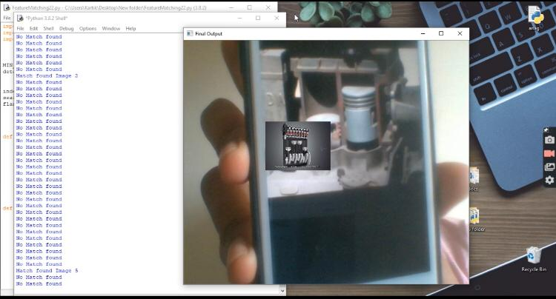

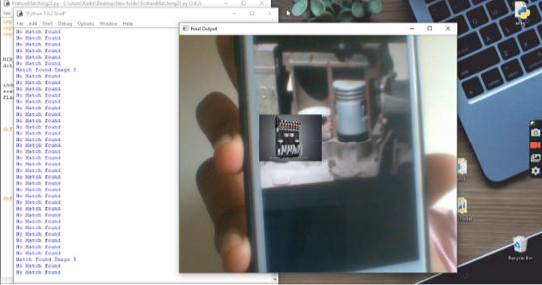

**CHAPTER 10**

**VIRTUAL REALITY**

* Virtual reality is viewing a video in 3D using special 3D glasses that gives users the immersive experience of being a part of that 3D movie.
* First the camera sensor is activated and the cartoon image is shown in order to play it’s corresponding video. Then the features are recognized in this frame and are compared to those images present in the database.
* ORB has been used for feature detection and BFmatcher (Brute Force) for feature matching.
* Once the features are detected and compared the image in the database which is most similar to the image shown by the user is determined.
* Then the video corresponding to the image is retrieved and played to the user. This is achieved by ffpyplayer module in our project.
* At the end of the video the program waits for an instruction whether to quit or continue; if the program hasn’t received any exit instruction then again the process gets repeated.

**10.1 CODE**

import cv2

import numpy as np

import os

from ffpyplayer.player import MediaPlayer

orb=cv2.ORB_create(nfeatures=5000)

path="imagesquery"

images=[]

classnames=[]

mylists=os.listdir(path)

print("Total classes detected", len(mylists))

for cl in mylists:

imgCur = cv2.imread(f'{path}/{cl}',0)

images.append(imgCur)

classnames.append(os.path.splitext(cl)[0])

def findDes(images):

desList=[]

for i in images:

kp,des=orb.detectAndCompute(i,None)

desList.append(des)

return desList

def findId(img,desList,thresh=40):

kp2,des2=orb.detectAndCompute(img,None)

bf =cv2.BFMatcher()

matchList=[]

finalVal=-1

try:

for des in desList:

matches=bf.knnMatch(des, des2, 2)

good=[]

for m,n in matches:

if m.distance< 0.75*n.distance:

good.append([m])

matchList.append(len(good))

except:

pass

if len(matchList)!=0 :

if max(matchList)>thresh :

finalVal=matchList.index(max(matchList))

return finalVal

desList=findDes(images)

cap= cv2.VideoCapture(0)

while True:

success,img2=cap.read()

imgOriginal=img2.copy()

img2 = cv2.cvtColor(img2,cv2.COLOR_BGR2GRAY)

cv2.imshow('imgOriginal',imgOriginal)

id = findId(img2, desList)

if id!=-1:

cv2.putText(imgOriginal,classnames[id],(50,50),cv2.FONT_HERSHEY_COMPLEX,1,(0,0,255),3)

video_path='videoss\\'+classnames[id]+'.mp4'

PlayVideo(video_path)

cv2.waitKey(1)

**10.2 OUTPUT VIDEO SCREENSHOTS:**

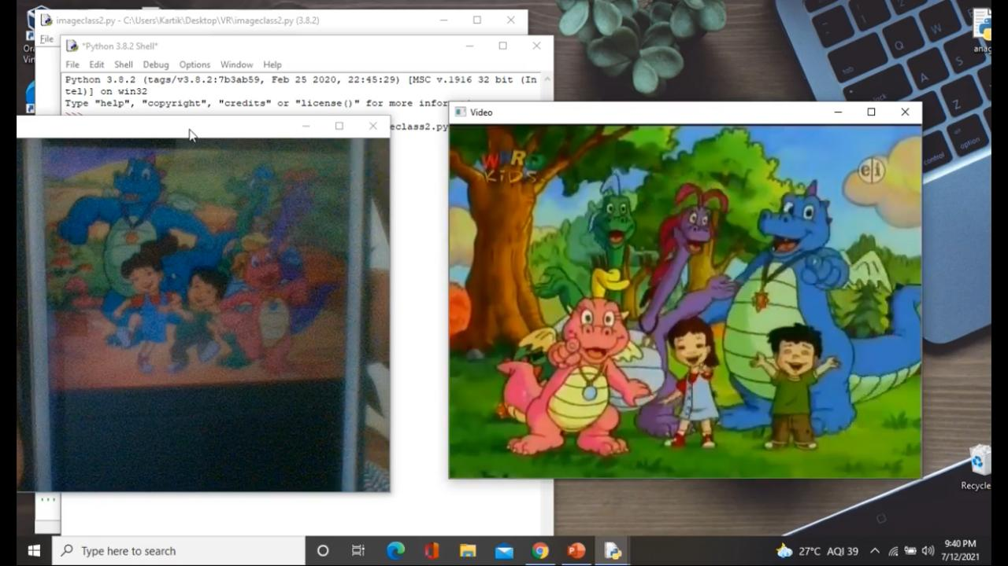

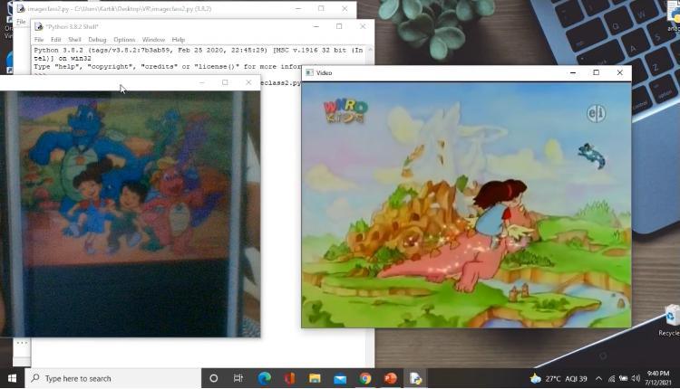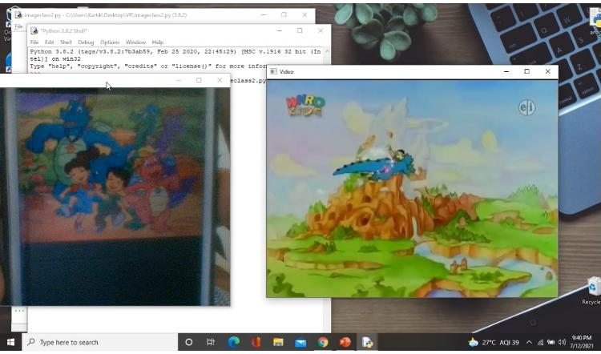

**CHAPTER 11**

**CONCLUSION AND FUTURE WORK**

In this project an easy way of teaching online classes with video explanation is done by using Augmented reality. ORB is used for Feature detection and Flann based matcher is used for Feature Matching to produce accurate results.A Virtual reality model is also developed where a particular video is played based on the image shown by the user. Even here ORB is used for feature detection and matching. Ffpyplayer is used for playing the corresponding video.

This work of Augmented reality can be extended even in medical or entertainment field. In medical field, the user can scan the image of the medicine to know its details in an app designed specially for this task. Then the detailed video describing about the medicine will be displayed to the user in their required language. Same procedure can be applied in entertainment field too by scanning a particular cartoon scene or a series scene a video from that scene of that respected cartoon or series is displayed to the user.

The work of virtual reality is mostly for entertainment where a user can feel that he/she is in that particular virtually created scene. This work can be extended and an app can be designed where it enables users to scan the image of a scene from a cartoon or series. This app is connected to the virtual reality device where the video corresponding to the image scanned is displayed in 3D format to the user.

**CHAPTER 12**

**REFERENCES**

* Z. Zhang, D. Weng, H. Jiang, Y. Liu and Y. Wang, "Inverse Augmented Reality: A Virtual Agent's Perspective," 2018 IEEE International Symposium on Mixed and Augmented Reality Adjunct (ISMAR-Adjunct), 2018, pp. 154-157, doi: 10.1109/ISMAR-Adjunct.2018.00056.
* J. Rozell et al., "Circuit World: A Multiplayer VE for Researching Engineering Learning," 2021 IEEE Conference on Virtual Reality and 3D User Interfaces Abstracts and Workshops (VRW), 2021, pp. 773-773, doi: 10.1109/VRW52623.2021.00272.
* C. Matthes et al., "The Collaborative Virtual Reality Neurorobotics Lab," 2019 IEEE Conference on Virtual Reality and 3D User Interfaces (VR), 2019, pp. 1671-1674, doi: 10.1109/VR.2019.8798289.
* C. Oikonomou, A. Lioret, M. Santorineos and S. Zoi, "Experimentation with the human body in virtual reality space: Body, bacteria, life-cycle," 2017 9th International Conference on Virtual Worlds and Games for Serious Applications (VS-Games), 2017, pp. 185-186, doi: 10.1109/VS-GAMES.2017.8056598.
* B. Hentschel, M. Wolter and T. Kuhlen, "Virtual Reality-Based Multi-View Visualization of Time-Dependent Simulation Data," 2009 IEEE Virtual Reality Conference, 2009, pp. 253-254, doi: 10.1109/VR.2009.4811041.
* S. A. Pessoa, G. de S. Moura, J. P. S. M. Lima, V. Teichrieb and J. Kelner, "A Global Illumination and BRDF Solution Applied to Photorealistic Augmented Reality," 2009 IEEE Virtual Reality Conference, 2009, pp. 243-244, doi: 10.1109/VR.2009.4811036.
* A. Baheti, S. Seshadri, A. Kumar, G. Srimathveeravalli, T. Kesavadas and K. Guru, "RoSS: Virtual Reality Robotic Surgical Simulator for the da Vinci Surgical System," 2008 Symposium on Haptic Interfaces for Virtual Environment and Teleoperator Systems, 2008, pp. 479-480, doi: 10.1109/HAPTICS.2008.4479999.
* G. Faidley et al., "Developing an integrated wireless system for fully immersive virtual reality environments," Eighth International Symposium on Wearable Computers, 2004, pp. 178-179, doi: 10.1109/ISWC.2004.14.
* Z. Zhang, B. Cao, J. Guo, D. Weng, Y. Liu and Y. Wang, "Inverse Virtual Reality: Intelligence-Driven Mutually Mirrored World," 2018 IEEE Conference on Virtual Reality and 3D User Interfaces (VR), 2018, pp. 735-736, doi: 10.1109/VR.2018.8446260.
* J. Schild et al., "EPICSAVE Lifesaving Decisions – a Collaborative VR Training Game Sketch for Paramedics," 2019 IEEE Conference on Virtual Reality and 3D User Interfaces (VR), 2019, pp. 1389-1389, doi: 10.1109/VR.2019.8798365.
* T. Blum, S. M. Heining, O. Kutter and N. Navab, "Advanced training methods using an Augmented Reality ultrasound simulator," 2009 8th IEEE International Symposium on Mixed and Augmented Reality, 2009, pp. 177-178, doi: 10.1109/ISMAR.2009.5336476.
* T. Blum, R. Stauder, E. Euler and N. Navab, "Superman-like X-ray vision: Towards brain-computer interfaces for medical augmented reality," 2012 IEEE International Symposium on Mixed and Augmented Reality (ISMAR), 2012, pp. 271-272, doi: 10.1109/ISMAR.2012.6402569.
* T. Blum, V. Kleeberger, C. Bichlmeier and N. Navab, "mirracle: An augmented reality magic mirror system for anatomy education," 2012 IEEE Virtual Reality Workshops (VRW), 2012, pp. 115-116, doi: 10.1109/VR.2012.6180909.
* M. Tonnis, L. Klein and G. Klinker, "Perception thresholds for augmented reality navigation schemes in large distances," 2008 7th IEEE/ACM International Symposium on Mixed and Augmented Reality, 2008, pp. 189-190, doi: 10.1109/ISMAR.2008.4637360.
* C. W. M. Leão, J. P. Lima, V. Teichrieb, E. S. Albuquerque and J. Kelner, "Altered reality: Augmenting and diminishing reality in real time," 2011 IEEE Virtual Reality Conference, 2011, pp. 219-220, doi: 10.1109/VR.2011.5759477.